**SAP-SD (BASIC TO ADVANCE)**

**Training Report submitted in partial fulfillment of the requirements for the   
award of the Degree of**

**MASTER OF BUSINESS ADMINISTRATION   
of  
BENGALURU CITY UNIVERSITY**



***By*  
Debapriya Nayak**

**Reg. No.**

**P18DZ23M015069**

**Under the guidance of  
PROF. HALEEMA TASNEEM  
PROFESSOR – Department of Management**

**Karnataka College of Management**

**Siva Prasad**

**Training Institution**

**UDEMY**

**Bengaluru City University**

**DECLARATION BY THE STUDENT**

**I hereby declare that “SAP-SD (BASIC TO ADVANCE) ” is the result of the training undergone by me in partial fulfillment for the award of Master’s Degree in Business Administration by Bengaluru City University.**

**I also declare that this report is the outcome of my own efforts and that it has not been submitted to any other University or Institute for the award of any other Degree or Diploma or Certificate.**

**Place: Bangalore Name : Debapriya Nayak**

**Date: 02/03/25 Register Number: P18DZ23M015069**

**Issued Certificate By UDEMY**

**Nexus Certificate Issued Certificate By BCU**



**`**

**GUIDE CERTIFICATE**

This is to certify that the Training Report “*Sap-SD (Basic to Advance)*” Submitted by **Debapriya Nayak P18DZ23M015069** to Bengaluru City University, Bengaluru for the award of Degree of Master of Business Administration is a record of work carried out by he/her under my guidance.

Place: Bangalore

Date: Signature

**CERTIFICATE OF ORIGINALITY**

This is to certify that the Training report entitled “*SAP-SD (BASIC TO ADVANCE)* ” is an original work of Mr. **Debapriya Nayak** bearing University Register Number **P18DZ23M015069** and is being submitted in partial fulfillment for the award of the Master’s Degree in Business Administration of Bengaluru City University. The report has not been submitted earlier either to this University /Institution for the fulfillment of the requirement of any course of study. **Mr. Debapriya Nayak** is guided by **Prof. HALEEMA TASNEEM** who is the Faculty Guide as per the regulations of Bengaluru City University.

SIGNATURE AND SEAL OF DIRECTOR / PRINCIPAL /HOD

**Training Project Work**

**PROGRESS REPORT**

|  |  |  |
| --- | --- | --- |
| **Sl. No.** | **Particulars** |  |
| 1 | Name of the Student | Debapriya Nayak |
| 2 | Registration Number | P18DZ23M015069 |
| 3 | Name of College Guide | Prof. HALEEMA TASNEEM |
| 4 | Name and contact no of the Co- Guide/External Guide (Corporate) | Siva Prasad |
| 5 | Name and Address of the Company/Organization where Training Project undertaken with start date | UDEMY  **Online Platform**  [WWW.UDEMY.COM](http://WWW.UDEMY.COM) |
| 6 | Progress report: A brief note reflecting, Number of meetings with Guides, places visited, libraries visited, books referred, meeting with persons, activities taken up, etc.,) | Met guide Prof. HALEEMA TASNEEM 5 times for feedback. libraries for research. Referred books on SAP -SD . Engaged with SAP consultants and industry experts. |

Date:

Signature of the Candidate Signature of the College Guide

**Acknowledgment**

I would like to express my sincere gratitude to all those who have contributed to the successful completion of my SAP-SD project.

Firstly, I extend my deepest appreciation to **BENGALURU CITY UNIVERSITY** And **KARNATAKA COLLEGE OF MANAGEMENT**  for providing me with the opportunity and resources to work on this project. I am especially grateful to my Internal Guide **Prof. HALEEMA TASNEEM**, for their continuous guidance, valuable insights, and unwavering support throughout this journey. Their expertise has been instrumental in shaping my understanding of SAP-SD processes and their real-world applications.

I would also like to thank my colleagues and team members for their cooperation and encouragement. Their inputs and discussions have greatly enriched my learning experience. Additionally, I am thankful to my family and friends for their constant motivation and support during this project.

Finally, I extend my appreciation to SAP trainer **Siva Prasad** , online resources, and all those who have shared their knowledge and experiences in the field of SAP Sales and Distribution (SD). Their contributions have helped me gain a deeper understanding of the subject and successfully complete this project.

This project has been a valuable learning experience, and I am grateful for the knowledge and skills I have gained throughout this journey…

**Debapriya Nayak  
03-03-2025**

**Table of Contents**

|  |  |  |
| --- | --- | --- |
| SL. NO | Chapter Title | Page No. |
| Chapter 1 | **Introduction** | **11-20** |
| Chapter 2 | **DESCRIPTION OF THE TRAINING** | **21-26** |
| Chapter 3 | **Training Outcome** | **27-30** |
| Chapter 4 | **Placement Opportunities** | **31-33** |
| Chapter 5 | **Learning Experience** | **34-36** |
|  | **Conclusion**  **&**  **Reference** | **37-38** |

**TABLE OF FIGURES**

|  |  |  |
| --- | --- | --- |
| **Figure no.** | **Figure Title** | **Page no.** |
| 1.1 | Introduction to SAP – Sales and Distribution | 12-14 |
| 1.2 | Importance of the Training Undergoing | 15-18 |
| 1.3 | Need for the Training Undergoing | 19-21 |
| 2.1 | Type of Training Undergoing | 23-25 |
| 2.2 | Usefulness of the Training Undergoing | 26-27 |
| 3.1 | Knowledge Acquired | 28-29 |
| 3.2 | Skills Mastered | 30-32 |
| 4.1 | Placement Opportunities in India | 33-34 |
| 4.2 | Global Placement Opportunities | 34-35 |
| 4.3 | Entrepreneurial Opportunities | 35 |
| 5.1 | Brief on New Skills Learned | 36 |
| 5.2 | Challenges Faced During Training | 37 |

**Training Project Work**

|  |  |  |
| --- | --- | --- |
| **Day** | **Date** | **Work Done** |
| Day 1 | **25-01-2025** | Overview of SAP SD & Order-to-Cash Cycle |
| Day 2 | **26-01-2025** | SAP GUI Navigation & Master Data (Customer & Material) |
| Day 3 | **27-01-2025** | Pricing Master Data (Condition Types, Access Sequence) |
| Day 4 | **28-01-2025** | Sales Document Structure & Types |
| Day 5 | **29-01-2025** | Sales Order Process Flow & Configuration |
| Day 6 | **30-01-2025** | Copy Control in Sales Documents |
| Day 7 | **31-01-2025** | Hands-on: Creating Sales Orders & Master Data Practice |
| Day 8 | **01-02-2025** | Delivery Process Overview & Document Structure |
| Day 9 | **02-02-2025** | Shipping Process & Picking Strategy |
| Day 10 | **03-02-2025** | Packing & Post Goods Issue |
| Day 11 | **04-02-2025** | Route Determination & Transportation in SAP SD |
| Day 12 | **05-02-2025** | Credit Management in SAP SD |
| Day 13 | **06-02-2025** | Special Sales Orders: Rush Order & Cash Sales |
| Day 14 | **07-02-2025** | Hands-on: Creating Delivery Documents & Processing Shipments |
| Day 15 | **08-02-2025** | Billing Process Overview & Types of Billing Docs |
| Day 16 | **09-02-2025** | Invoice Generation & Output Determination |
| Day 17 | **10-02-2025** | Handling Returns & Credit Memos |
| Day 18 | **11-02-2025** | Copy Control in Billing & Customizing Billing Docs |
| Day 19 | **12-02-2025** | Hands-on: Creating Billing & Return Processes |
| Day 20 | **13-02-2025** | SAP SD Reports & Analytics |
| Day 21 | **14-02-2025** | Integration with MM & FI Modules |
| Day 22 | **15-02-2025** | Pricing Procedures & Customizing |
| Day 23 | **16-02-2025** | Revenue Account Determination |
| Day 24 | **17-02-2025** | Special Business Scenarios & Intercompany Sales |
| Day 25 | **18-02-2025** | SAP SD User Exits & Enhancements |
| Day 26 | **19-02-2025** | Configuration of SD-FI Integration |
| Day 27 | **20-02-2025** | Customization & Real-time Scenarios |
| Day 28 | **21-02-2025** | Final Hands-on Practice & Mock Project |
| Day 29 | **22-02-2025** | Revision & Q&A Session |
| Day 30 | **23-02-2025** | Final Test & Certification Preparation |

**Day-wise Training Report**

**Signature of the Student Signature of the Guide**

**Executive Summary**

This report provides a comprehensive overview of the SAP SD (Sales and Distribution) training undertaken as part of professional certification. The training aimed to develop expertise in handling the Order-to-Cash (O2C) process, including sales order management, pricing, billing, shipping, and integration with other SAP modules like SAP MM (Material Management) and SAP FICO (Finance & Controlling). The training was structured to provide both theoretical knowledge and hands-on practical experience using SAP ERP systems to configure and execute various sales and distribution operations.

The report begins with an introduction to the training, emphasizing its importance and relevance in modern business processes. It highlights the need for SAP SD skills in today's competitive job market, where companies rely on ERP solutions to streamline sales, distribution, and customer relationship management.

The next section details the type of training undergone, including key learning modules such as master data management, order processing, pricing procedures, credit management, and logistics execution. The usefulness of the training is discussed in terms of its impact on business efficiency, automation, and financial accuracy.

The training outcome section outlines the knowledge acquired and skills mastered, such as configuring sales documents, managing pricing conditions, and integrating SAP SD with financial transactions. A practical demonstration of operations is included through photographs and video documentation, showcasing real-time application of SAP SD functionalities.

The report also explores placement opportunities in India and globally, analysing career prospects for SAP SD professionals in industries like IT, manufacturing, retail, and logistics. Additionally, entrepreneurial opportunities for SAP SD consultants are briefly discussed.

Finally, the learning experience section highlights key takeaways from the training, including new skills acquired and challenges faced during the learning process. Overall, this report serves as a reflection of the SAP SD training program, demonstrating its significance in business operations and its role in enhancing career prospects in the field of SAP ERP and enterprise solutions.

# CHAPTER - 1

**1.1 INTRODUCTION TO SAP – SALES AND DISTRIBUTION**

**1.1.1 INTRODUCTION of SAP- SD**

Organizations need powerful and effective systems in today's business world to perform their sales and distribution activities. SAP Sales and Distribution (SAP SD) is one of the major SAP ERP modules responsible for executing end-to-end sales processes from managing orders to deliveries and billing. This project concentrates on comprehending the capabilities of SAP SD and its utilization to streamline business functions.

SAP SD is very important in making the order-to-cash (O2C) process smoother, allowing efficient transactions between organizations and their clients. It incorporates different sub-modules such as customer and material master data, price, sales order management, shipping, delivery, billing, and credit management. This project will examine these parts and assess their importance in boosting operational efficiency.

Besides, SAP SD integrates very well with other SAP modules like FI (Financial Accounting), CO (Controlling), MM (Materials Management), and PP (Production Planning) to make for a smooth business workflow. In this project, we will go through real-life use cases and study how businesses use SAP SD to increase productivity, boost customer satisfaction, and decrease operational risks.

The main goals of this project are to:

* Understand the fundamental features of SAP SD and its business influence.
* Examine the integration of SAP SD with other SAP modules.
* Assess challenges in SAP SD implementation and suggest possible solutions.
* Illustrate practical uses of SAP SD in real-life business situations.

Through this research, we seek to learn more about the ways in which SAP SD enables effective sales processes, proper financial reporting, and effective logistics management. This study will give important insights into the strategic position of SAP SD in contemporary businesses and how it can develop further.

**1.1.2 Purpose of the Training and Its Relevance in Business Processes**

The purpose of SAP SD (Sales and Distribution) training is to equip professionals with the necessary skills to efficiently manage and optimize sales processes within an organization. SAP SD is a crucial module of SAP ERP, widely used by businesses worldwide to handle sales transactions, pricing, billing, and distribution. This training helps individuals gain in-depth knowledge of the Order-to-Cash (O2C) cycle, customer relationship management, and integration with other SAP modules such as SAP MM (Material Management) and SAP FICO (Finance and Controlling).

One of the key reasons for undergoing this training is to understand and configure business processes in a structured manner. Companies rely on SAP SD to automate sales order processing, reduce manual errors, and ensure smooth transactions from order creation to final payment. This module helps businesses manage customer data, maintain pricing conditions, and track inventory, which are critical for efficient supply chain management. Additionally, training in SAP SD enables professionals to handle credit management, risk assessment, and returns processing, ensuring companies maintain financial stability while serving their customers effectively.

The relevance of SAP SD training in business processes is significant as it enhances customer satisfaction, operational efficiency, and financial accuracy. Businesses can streamline their sales and distribution channels, reduce lead times, and improve revenue tracking through real-time insights. Furthermore,

organizations transition to SAP S/4HANA, professionals with SAP SD expertise are in high demand to support digital transformation initiatives.

In conclusion, SAP SD training is essential for anyone looking to build a career in SAP consulting, sales operations, or enterprise resource planning (ERP). It provides the technical skills and functional understanding necessary to help businesses manage their sales workflows efficiently, optimize resource utilization, and drive overall profitability. This training is particularly beneficial for IT professionals, business analysts, and finance professionals who want to specialize in SAP solutions and contribute to an organization’s growth and success.

**1.1.3. Key Areas Covered in SAP SD**

The SAP Sales and Distribution (SAP SD) module plays a crucial role in managing business transactions related to sales, order processing, billing, and logistics. It ensures a seamless flow of information between sales, inventory management, and financial accounting. The key areas covered in SAP SD training include:

**1. Order-to-Cash (O2C) Cycle**

The Order-to-Cash (O2C) process is the backbone of SAP SD, covering the entire journey of a sales transaction from order creation to payment collection. The main stages in this cycle include:

* Inquiry & Quotation: Capturing customer inquiries and generating quotations.
* Sales Order Processing: Creating sales orders with material details, pricing, and delivery schedules.
* Availability Check & Credit Management: Ensuring product availability and verifying customer credit limits.
* Delivery Processing: Picking, packing, and dispatching goods from the warehouse.
* Billing & Invoicing: Generating invoices for customers and posting them to financial accounts.
* Payment Processing: Managing incoming payments and financial reconciliation.

This cycle integrates sales, inventory, and financial management, ensuring smooth order fulfilment and revenue tracking.

**2. Pricing & Discounts Management**

Pricing in SAP SD is handled using condition techniques, allowing businesses to set up flexible pricing models. The training covers:

* Condition Types: Base price, discounts, surcharges, taxes, and freight costs.
* Pricing Procedure: Defining the sequence of price calculations.
* Customer-Specific Pricing: Special discounts for different customers or bulk orders.
* Promotions & Rebates: Configuring seasonal discounts and loyalty rewards.

Pricing is a critical component that helps businesses maximize profits while maintaining competitive pricing strategies.

**3. Billing & Invoicing**

The billing process in SAP SD ensures accurate financial transactions and revenue management. The key aspects include:

* Invoice Generation: Automatic creation of invoices after delivery.
* Billing Types: Proforma invoices, credit memos, debit memos, and cancellation invoices.
* Integration with FICO: Automatic posting of revenue and accounts receivable.
* Tax Calculation: Application of GST, VAT, and other regional tax rules.

This ensures businesses maintain compliance with financial regulations while automating the invoicing process.

**4. Logistics & Shipping Management**

SAP SD ensures efficient logistics and transportation management, covering:

* Delivery Scheduling: Planning delivery dates based on stock availability.
* Picking & Packing: Generating warehouse picking lists and packing instructions.
* Goods Issue & Tracking: Updating stock movements and tracking shipments.
* Returns & Refunds: Managing product returns, issuing credit memos, and handling customer complaints.

These functionalities improve supply chain efficiency and enhance customer satisfaction through on-time deliveries.

**5. Integration with SAP MM & SAP FICO**

SAP SD does not function in isolation; it integrates with other SAP modules:

🔹 Integration with SAP MM (Material Management):

* Stock availability check for sales orders.
* Automatic material requirement planning (MRP).
* Goods issue updates in inventory after sales.

🔹 Integration with SAP FICO (Finance & Controlling):

* Posting invoices in financial accounts.
* Revenue recognition and profit calculation.
* Credit control and risk management.

This integration ensures seamless coordination between sales, inventory, and finance departments, enhancing overall business operations.

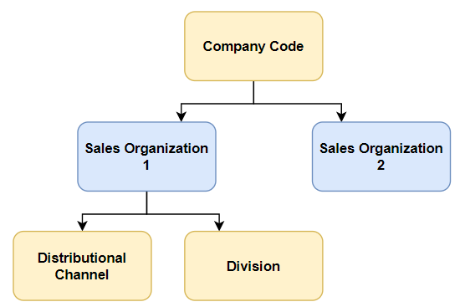

**SAP SALES DISTRIBUTION**

**1.2 Importance of the Training Undergoing**

**1.2.1 Enhancing Expertise in Sales and Distribution Management Through SAP SD**

The SAP Sales and Distribution (SAP SD) module plays a crucial role in streamlining and optimizing sales and distribution processes within an organization. It enhances expertise in managing the complete Order-to-Cash (O2C) cycle, from customer inquiry and order creation to delivery, invoicing, and payment collection. By mastering SAP SD, professionals gain the ability to automate and improve sales workflows, ensuring seamless transactions, accurate financial reporting, and efficient logistics management.

**1. In-Depth Knowledge of Sales Order Processing**

SAP SD provides hands-on experience in handling end-to-end sales processes, including:

* Creating sales orders, tracking their status, and managing changes.
* Understanding customer master data and its impact on order processing.
* Automating availability checks, ensuring products are in stock before confirming orders.
* Implementing credit management, preventing financial risks associated with overdue payments.

These skills help professionals manage sales transactions more effectively, reducing manual errors and improving order accuracy.

**2. Mastering Pricing and Discount Strategies**

A key function of sales management is pricing, and SAP SD provides a robust framework for handling complex pricing scenarios. The training helps professionals understand:

* Condition-Based Pricing: Setting base prices, discounts, taxes, and surcharges based on customer segments.
* Special Pricing Agreements: Managing promotions, rebates, and customer-specific pricing.
* Profitability Analysis: Assessing pricing models to maximize revenue and maintain competitive pricing strategies.

By mastering SAP SD pricing mechanisms, professionals can help businesses increase sales revenue while maintaining competitive pricing models.

**3. Efficient Logistics and Delivery Management**

SAP SD enhances expertise in shipping and distribution, ensuring timely and accurate deliveries. The module covers:

* Delivery Scheduling: Planning delivery dates based on stock availability and transportation.
* Warehouse Management: Integrating with SAP MM for stock movement and inventory updates.
* Returns and Refunds Handling: Managing product returns efficiently and ensuring customer satisfaction.

By understanding logistics management in SAP SD, professionals contribute to reducing delivery errors, improving efficiency, and optimizing supply chain operations.

**4. Seamless Integration with Finance and Inventory Management**

SAP SD professionals gain expertise in integrating sales with SAP FICO (Finance and Controlling) and SAP MM (Material Management) to ensure accurate financial tracking and inventory control. Key learning points include:

* Financial Posting of Sales Transactions: Ensuring that invoices, payments, and revenue are automatically recorded in financial accounts.
* Inventory Management: Automating stock updates upon sales and returns.
* Credit Risk Analysis: Evaluating customers' creditworthiness before processing large sales orders.

This integration improves business transparency by ensuring that sales, finance, and inventory teams work together efficiently.

**5. Data-Driven Decision Making with SAP SD Reports**

SAP SD provides advanced reporting and analytics to help businesses make informed decisions. Professionals gain expertise in:

* Sales Forecasting: Predicting future sales trends based on historical data.
* Customer Buying Behaviour Analysis: Identifying purchasing patterns to optimize marketing strategies.
* Profit and Loss Tracking: Analysing revenue and cost impact to improve financial planning.

By leveraging real-time sales data, organizations can improve their business strategy, enhance customer experience, and boost overall profitability.

**1.2.2. Improving Business Process Automation and Efficiency Through SAP SD**

The SAP Sales and Distribution (SAP SD) module plays a critical role in improving business process automation and operational efficiency by streamlining sales, order management, pricing, billing, and distribution processes. By implementing SAP SD, organizations can eliminate manual tasks, reduce errors, and enhance the speed and accuracy of sales transactions, ultimately leading to better productivity and customer satisfaction.

**1. Automating Sales Order Processing**

One of the primary ways SAP SD improves business efficiency is through the automation of sales order processing. Traditionally, sales orders were managed manually, leading to errors, delays, and inefficiencies. With SAP SD, businesses can:

* Auto-generate sales orders from inquiries and quotations.
* Perform real-time availability checks to confirm stock before order creation.
* Implement workflow automation, ensuring faster order approvals and processing.
* Reduce manual data entry errors by using predefined templates and customer master data.

This automation results in faster order fulfilment, fewer discrepancies, and improved operational efficiency.

**2. Streamlining Pricing and Discount Management**

SAP SD allows businesses to automate pricing calculations, reducing the complexity of handling multiple price lists, discounts, and taxes. The pricing procedure in SAP SD ensures:

* Dynamic price determination based on pre-configured rules.
* Automatic application of discounts, rebates, and surcharges without manual intervention.
* Tax calculations that comply with different regional and international regulations.

This automation minimizes pricing errors, ensures consistent pricing strategies, and reduces the workload of sales teams.

**3. Enhancing Logistics and Delivery Operations**

SAP SD integrates with SAP MM (Material Management) and SAP WM (Warehouse Management) to automate delivery scheduling, shipping, and inventory updates. Businesses benefit from:

* Automated delivery creation linked to sales orders.
* Real-time stock updates, ensuring accurate inventory management.
* Barcode scanning and tracking, reducing manual errors in picking and packing.
* Automatic shipment notifications, improving communication between suppliers and customers.

By optimizing logistics and minimizing manual intervention, SAP SD helps businesses reduce delays, lower operational costs, and improve customer satisfaction.

**4. Faster and More Accurate Billing and Invoicing**

Manual billing processes can be slow and prone to errors. SAP SD automates invoice generation based on predefined rules, ensuring:

* Error-free invoices with accurate pricing, tax calculations, and customer details.
* Automatic financial postings to SAP FICO for revenue recognition.
* Seamless credit management, preventing fraudulent transactions or over-crediting.
* Integration with payment gateways, enabling faster payment processing.

This leads to faster revenue collection, better financial control, and improved cash flow management.

**5. Efficient Credit Management and Risk Control**

SAP SD includes built-in credit management tools that help businesses monitor customer credit limits and reduce financial risks. The system:

* Automatically checks credit limits before approving high-value orders.
* Blocks high-risk transactions until further review, reducing potential bad debts.
* Automates follow-ups for overdue payments, improving accounts receivable management.

With these features, businesses can ensure financial stability and reduce losses due to unpaid invoices.

**6. Data-Driven Decision Making with Real-Time Analytics**

SAP SD provides advanced reporting and analytics tools that help businesses make data-driven decisions. Some key benefits include:

* Sales performance tracking using real-time dashboards.
* 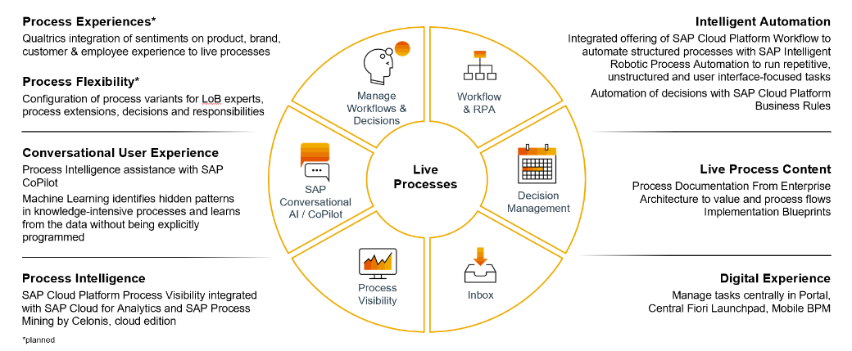Customer buying behavior analysis, helping businesses tailor marketing strategies.
* Profitability insights, allowing companies to optimize pricing and sales efforts.

Automating these reports eliminates manual data compilation, saving time and ensuring accurate business insights for decision-makers

**1.2.3.Helps in Career Advancement in SAP Consulting, Business Analysis, and IT Implementation**

Completing SAP SD (Sales and Distribution) certification significantly enhances career opportunities in SAP consulting, business analysis, and IT implementation by equipping professionals with in-demand skills in enterprise resource planning (ERP).

**1. Career in SAP Consulting**

SAP SD professionals can work as SAP SD Consultants, helping companies implement, configure, and optimize SAP systems to improve their sales and distribution processes. Consultants analyze business requirements, customize SAP solutions, and train end-users. SAP consulting roles are highly sought after in IT firms, multinational corporations, and SAP partner companies, offering lucrative salaries and global career prospects.

**2. Business Analysis Opportunities**

With SAP SD expertise, professionals can transition into business analyst roles, where they bridge the gap between technical SAP teams and business stakeholders. Business analysts use SAP SD reports and analytics to help organizations make data-driven decisions, improve customer relationship management, and streamline sales operations.

**3. IT Implementation and Project Management**

SAP SD professionals also play a vital role in ERP implementation projects, ensuring smooth integration of SAP SD with SAP MM (Material Management) and SAP FICO (Finance & Controlling). They assist in system upgrades, process automation, and troubleshooting, making them valuable assets for IT service providers and in-house ERP teams.

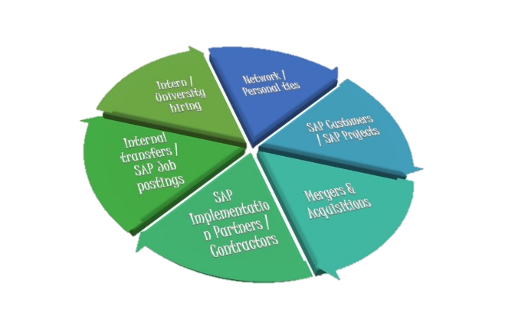

**1.3 Need for the Training Undergoing**

**1.3.1**. **High Demand for SAP SD Professionals in Various Industries**

The demand for SAP SD (Sales and Distribution) professionals is rapidly increasing as companies across industries rely on SAP ERP to streamline their sales, order processing, and distribution management. Organizations seek trained professionals who can optimize SAP SD functionalities, enhance business automation, and integrate sales processes with finance, inventory, and logistics.

**1. Growing Adoption of SAP in Global Industries**

Companies worldwide are transitioning to SAP S/4HANA, creating a surge in demand for SAP SD consultants, business analysts, and IT professionals. Industries that heavily depend on SAP SD include:

* Manufacturing – Managing large-scale product distribution and sales tracking.
* Retail & E-commerce – Automating customer orders, pricing, and billing processes.
* Logistics & Supply Chain – Handling shipping, order fulfillment, and warehouse integration.
* Finance & Banking – Ensuring accurate financial posting of sales transactions.
* Healthcare & Pharmaceuticals – Managing product sales and distribution compliance.

**2. Need for SAP SD Experts in ERP Implementation**

With companies migrating from legacy systems to SAP S/4HANA, there is a significant need for professionals who:

* Configure SAP SD modules for smooth sales and distribution operations.
* Integrate SAP SD with SAP MM (Material Management) and SAP FICO (Finance & Controlling).
* Optimize pricing procedures, billing automation, and sales analytics.

**3. Career Opportunities and Competitive Salaries**

Due to the growing demand, SAP SD professionals receive attractive salaries and global career opportunities:

* India: ₹6 – 15 LPA for SAP SD consultants.
* USA: $80,000 – $120,000 per year.
* Europe: €60,000 – €100,000 per year.

**1.3.2 Growing Importance of ERP Systems for Business Operations**

Enterprise Resource Planning (ERP) systems have become an essential tool for businesses looking to streamline operations, improve efficiency, and enhance decision-making. With the increasing complexity of modern business processes, organizations across industries are adopting ERP solutions like SAP S/4HANA to integrate and automate various functions, including sales, finance, supply chain, inventory, and human resources.

**1. Centralized Data Management for Better Decision-Making**

ERP systems eliminate data silos by providing a centralized platform where all business departments can access and share real-time information. This ensures:

* Accurate sales forecasting through real-time analytics.
* Improved financial reporting with automated revenue tracking.
* Better inventory control by integrating sales and material management.

🔹 Business Impact: Faster decision-making, improved collaboration, and enhanced operational transparency.

**2. Automation and Efficiency in Business Processes**

ERP systems like SAP SD reduce manual work and increase process efficiency by automating:

* Sales Order Processing: Faster order creation, pricing, and delivery scheduling.
* Billing & Invoicing: Automatic invoice generation and financial posting.
* Supply Chain Management: Real-time tracking of materials and logistics.

🔹 Business Impact: Reduced operational costs, fewer errors, and faster customer service.

**3. Scalability and Compliance**

As businesses expand, ERP systems support scalability by accommodating multi-location, multi-currency, and tax compliance requirements.

* Global tax compliance (e.g., GST, VAT) through automated calculations.
* Integration with e-commerce & CRM systems for seamless business expansion.
* Cloud-based ERP adoption enabling remote access and flexible operations.

🔹 Business Impact: Future-ready business operations with compliance and global expansion capabilities**.**

**1.3.3. Helps businesses streamline sales, customer service, and invoicing processes**

SAP SD (Sales and Distribution) plays a crucial role in automating and optimizing sales operations, customer interactions, and invoicing processes, ensuring efficiency and accuracy. Businesses across industries rely on SAP SD to reduce manual workload, enhance customer satisfaction, and improve revenue tracking.

**1. Sales Process Automation**

SAP SD **automates the entire Order-to-Cash (O2C) cycle**, reducing manual errors and ensuring smooth sales transactions. Key features include:

* **Fast Sales Order Processing:** Automates order entry, pricing, and stock availability checks.
* **Real-Time Inventory Updates:** Ensures product availability before order confirmation.
* **Integrated Credit Management:** Prevents financial risks by checking customer credit limits before processing sales.

🔹 **Business Impact:** Reduced processing time, fewer errors, and improved sales efficiency.

**2. Enhanced Customer Service**

With SAP SD, businesses can provide **better customer service and relationship management** by:

* **Automating Order Tracking:** Customers receive real-time updates on their orders and deliveries.
* **Faster Complaint Resolution:** Integrated return management ensures quick replacements and refunds.
* **Personalized Pricing & Discounts:** Businesses can offer targeted discounts and loyalty rewards.

🔹 **Business Impact:** Increased customer satisfaction, improved loyalty, and faster issue resolution.

**3. Streamlined Invoicing and Billing**

SAP SD automates **billing and financial reconciliation**, ensuring accurate invoicing and compliance. It includes:

* **Automated Invoice Generation:** Generates invoices instantly after delivery, reducing manual work.
* **Integration with SAP FICO:** Automatically posts revenue and accounts receivable for financial accuracy.
* 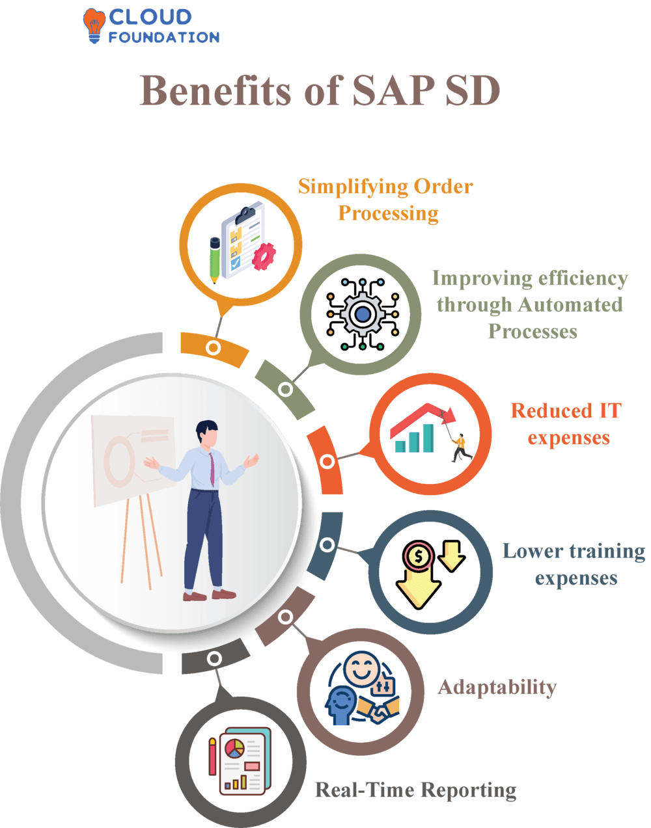**Tax Compliance:** Ensures invoices meet regional tax regulations like GST, VAT, and sales tax.
* **Business Impact:** Faster payment processing, reduced billing errors, and improved cash flow.

**Chapter 2**

**DESCRIPTION OF THE TRAINING**

SAP-SD Certification on Udemy

The SAP SD (Sales and Distribution) certification was completed through the Udemy platform, consisting of 31.5 hours of online training sessions. This training provided a structured approach to understanding sales order processing, pricing, billing, shipping, and integration with other SAP modules like SAP MM (Material Management) and SAP FICO (Finance & Controlling).

The training was designed to be self-paced, allowing flexibility in learning while covering both theoretical concepts and hands-on practical exercises. The course included video lectures, real-time system demonstrations, quizzes, and assignments, ensuring a comprehensive understanding of SAP SD functionalities.

Key Highlights of the Training:

Total Duration: 31.5 hours of in-depth SAP SD learning.

* Mode of Learning: Online (Self-paced video lectures).
* Training Platform: Udemy.
* Core Topics Covered:
  + SAP SD Master Data Management (Customer, Material, Pricing).
  + Order-to-Cash (O2C) Process and sales order creation.
  + Pricing and Discount Configuration using condition techniques.
  + Delivery Processing and Logistics Management.
  + Billing and Invoice Generation with financial integration.
  + SAP SD Reports and Analytics for decision-making.

This training enhanced technical expertise in SAP SD, providing real-world insights into sales operations, business process automation, and ERP system configuration. By completing this certification, valuable skills were acquired for SAP SD consulting, ERP implementation, and business process optimization.

**2.1**

**2.1 Type of Training Undergoing**

**2.1.1.Type of Training Undergoing – Online Mode**

The SAP SD training was conducted in an online mode in UDEMY providing a flexible and accessible learning environment. The training included video lectures, live instructor sessions, hands-on practice, and self-paced learning materials. Online training allowed learners to access course content from anywhere, making it convenient for working professionals and students.

**Some key features of the online training mode include:**

* Pre-Recorded Video Lectures – Covered theoretical concepts and practical demonstrations.
* Hands-On Practice – Provided access to an SAP sandbox system for real-world simulations.
* Quizzes & Assignments – Helped assess understanding and reinforce key concepts.
* 24/7 Learning Access – Allowed flexibility to learn at a personalized pace.

🔹 Business Impact: The online training method ensured learners could gain in-depth SAP SD knowledge while balancing their professional or academic commitments. It also provided real-time exposure to SAP tools and functionalities, making them industry-ready

**2.1.2. Certification Details – SAP SD Module, Duration, and Syllabus Covered**

**SAP SD Certification Overview**

The SAP SD (Sales and Distribution) certification validates expertise in managing sales, order processing, pricing, billing, and logistics within the SAP ERP system. This certification is widely recognized across industries and helps professionals advance their careers in SAP consulting, business analysis, and IT implementation.

* Total Duration: 31.5 hours
* Mode of Learning: Online (Instructor-led sessions)
* Assessment: Quizzes, Assignments, and a Final Certification Exam
* Certification Body: SAP-SD Plain English

**Syllabus Covered in SAP SD Training**

The training was structured into multiple modules, covering both theoretical concepts and hands-on practice. The key topics included:

1. SAP SD Introduction & Master Data Management

* Overview of SAP SD module and its integration with SAP MM & SAP FICO
* Customer Master Data, Material Master Data, Pricing Master Data

2. Sales Order Processing & Order-to-Cash (O2C) Cycle

* Sales Inquiry, Quotation, Sales Order, and Order Confirmation
* Credit Management, Availability Check, and Delivery Scheduling

3. Pricing and Discount Management

* Condition Techniques, Pricing Procedures, and Customer-Specific Pricing
* Taxes, Freight Charges, Rebates, and Discounts Configuration

4. Shipping and Delivery Management

* Delivery Processing, Picking, Packing, and Goods Issue
* Integration with Logistics and Warehouse Management

5. Billing and Invoice Processing

* Invoice Generation, Credit & Debit Notes, Financial Postings
* Taxation and Compliance Handling in SAP SD

6. SAP SD Reporting and Analytics

* Sales Performance Tracking, Order Backlogs, and Profitability Analysis
* SAP SD Standard Reports and Custom Report Generation

7. SAP SD Integration with SAP MM & SAP FICO

* Inventory and Stock Updates during Sales
* Revenue Recognition and Financial Posting in SAP FICO

8. Case Studies

* Real-life implementation scenarios
* Simulated projects for end-to-end SAP SD process execution

🔹 Business Impact: Completing this training and certification ensures proficiency in handling enterprise sales and distribution processes, making professionals job-ready for SAP SD consultant, business analyst, or ERP implementation roles.

**2.1.3. Hands-On Practice Using SAP Systems**

Practical Learning Approach in SAP SD Training

The SAP SD training included extensive hands-on practice using SAP ERP systems, allowing learners to apply theoretical knowledge in real-world business scenarios. This practical exposure was essential in understanding the Order-to-Cash (O2C) process, pricing configuration, billing automation, and integration with other SAP modules like SAP MM (Material Management) and SAP FICO (Finance & Controlling).

Hands-On Exercises and Simulations

Throughout the training, learners worked on SAP sandbox environments to gain expertise in:

* Sales Order Processing (VA01, VA02, VA03) – Creating, modifying, and tracking sales orders.
* Pricing & Discounts Configuration (VK11, VK12, VK13) – Setting up condition records for pricing, discounts, and taxes.
* Delivery Processing (VL01N, VL02N, VL03N) – Managing picking, packing, and goods issue.
* Billing & Invoicing (VF01, VF02, VF03) – Generating invoices, credit memos, and posting financial transactions.
* Customer & Material Master Data Management (XD01, XD02, MM01, MM02) – Maintaining master records for accurate transaction execution.
* Reports & Analysis (V/LD, MCTA, SD01) – Generating sales performance reports and tracking revenue trends.

Live System Simulations & Real-World Case Studies

Learners were given business case studies to simulate real-world challenges and execute SAP SD transactions accordingly. This included:

* Order Processing for an E-commerce Business – Managing customer orders, applying discounts, and generating invoices.
* Sales & Distribution for a Manufacturing Company – Handling stock transfers, order fulfillment, and payment tracking.

**2.2 Usefulness of the Training Undergoing**

The **SAP SD training** provided valuable knowledge and hands-on experience in managing **sales, distribution, and billing processes** within an enterprise. This training enhanced **technical expertise, business process understanding, and ERP implementation skills**, making it highly beneficial for career growth.

**Key Benefits of the Training:**

* **Improved Sales Process Management** – Enabled automation of sales orders, pricing, and customer data management.
* **Hands-on SAP System Experience** – Provided real-world exposure to SAP transactions, enhancing problem-solving skills.
* **Better Understanding of Business Integration** – Covered SAP SD’s role in connecting with **SAP MM (inventory) and SAP FICO (finance)**.
* **Increased Career Opportunities** – Opened job prospects in **SAP consulting, business analysis, and ERP implementation**.
* **Enhanced Decision-Making Skills** – Enabled data-driven sales forecasting and revenue tracking through SAP SD reports

**2.2.1 Ability to Configure and Manage Sales Order Processes**

The SAP SD training provided in-depth knowledge and practical experience in configuring and managing sales order processes, which are critical for ensuring smooth business transactions. The Order-to-Cash (O2C) cycle is the foundation of SAP SD, allowing businesses to handle customer inquiries, process orders, manage deliveries, and generate invoices efficiently.

**Key Sales Order Management Skills Acquired**

* Sales Order Creation (VA01, VA02, VA03) – Configuring and processing customer sales orders, including material selection, pricing, and quantity management.
* Availability Check & Credit Management – Ensuring stock availability and verifying customer credit limits before confirming orders.
* Order Scheduling & Delivery Management (VL01N, VL02N) – Automating order fulfilment by scheduling deliveries and tracking shipments.
* Pricing & Discount Application (VK11, VK12) – Configuring condition-based pricing, customer-specific discounts, and tax calculations.
* 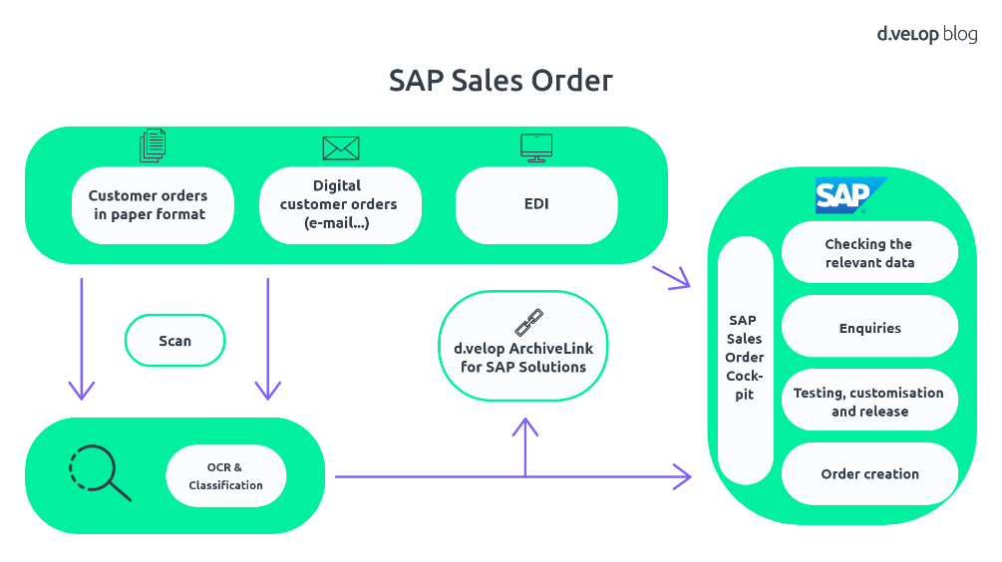Order Modifications & Returns Handling – Managing changes in orders, handling cancellations, and processing return requests efficient

**2.2.2. Understanding Pricing and Discount Mechanisms**

The SAP SD training provided a comprehensive understanding of pricing and discount mechanisms, which are essential for ensuring accurate and competitive pricing in sales transactions. SAP SD uses a condition technique to determine the final price of a product or service, taking into account various factors such as base price, discounts, taxes, and surcharges.

Key Pricing and Discount Concepts Learned

* Condition Types and Pricing Elements – Understanding different condition types, including base price, discounts, freight charges, and taxes.
* Pricing Procedure Configuration – Defining and sequencing condition types to determine the final sales price automatically.
* Customer-Specific Pricing (VK11, VK12) – Setting up personalized pricing structures for different customers based on agreements.
* Discount and Rebate Management – Configuring cash discounts, quantity-based discounts, promotional offers, and rebate agreements to enhance customer satisfaction.
* Tax Calculation and Compliance – Ensuring accurate application of regional and international taxes such as GST, VAT, and sales tax.

**2.2.3. Gaining knowledge of logistics, shipping, and billing integration**

The SAP SD training provided an in-depth understanding of howlogistics, shipping, and billing processes are integrated within the SAP system to ensure smooth order fulfillment and financial accuracy. Managing these processes efficiently is essential for maintaining customer satisfaction, timely deliveries, and accurate invoicing.

Key Logistics and Shipping Concepts Learned

* Delivery Processing (VL01N, VL02N, VL03N) – Creating and managing deliveries based on confirmed sales orders.
* Picking and Packing (LT03, LT12) – Handling warehouse operations, ensuring the right products are picked and packed for shipment.
* Goods Issue (PGI – Post Goods Issue) – Updating inventory levels and triggering financial postings upon shipment.
* Shipping and Transportation Management – Tracking shipments, managing freight costs, and optimizing delivery schedules.

**Key Billing Integration Concepts Learned**

* Invoice Generation (VF01, VF02, VF03) – Automating the billing process and generating customer invoices.
* Integration with SAP FICO – Ensuring financial postings, revenue recognition, and accounts receivable updates.
* Credit and Debit Notes – Managing corrections in billing, processing refunds, and handling customer disputes.

# CHAPTER – 3

**Training Outcome**

**3.1 Knowledge Acquired**

The SAP SD training covered essential concepts and hands-on practice in sales and distribution management within SAP ERP. The course provided in-depth knowledge of master data configuration, the Order-to-Cash (O2C) cycle, pricing, billing, shipping, and integration with SAP MM and SAP FICO. Through practical exercises, I gained the ability to create and manage sales orders, configure pricing conditions, handle deliveries, generate invoices, and process customer returns. Understanding enterprise structure, sales document types, and credit management further enhanced my expertise. This training has equipped me with the necessary skills to work efficiently in SAP SD consulting, business analysis, and ERP implementation roles.

**3.1.1**. **SAP SD Master Data Management (Customer, Material, Pricing)**

Master Data Management in SAP SD is a crucial aspect of ensuring accurate and efficient sales and distribution operations. The training provided in-depth knowledge of how customer data, material data, and pricing data are maintained and utilized in various sales processes.

**Customer Master Data**

The Customer Master contains essential details about customers that are required for sales order processing and billing. Key aspects include:

* General Data – Name, address, contact details, and industry type.
* Sales Area Data – Sales organization, distribution channel, and division.
* Company Code Data – Payment terms, reconciliation account, and credit management details.
* Transaction Codes: XD01 (Create), XD02 (Change), XD03 (Display).

**Material Master Data**

The Material Master stores information about products and services offered by a company. Key components include:

* Basic Data – Material description, unit of measure, and weight.
* Sales Data – Item category group, delivering plant, and tax classification.
* Pricing Data – Standard price, cost price, and discount eligibility.
* Transaction Codes: MM01 (Create), MM02 (Change), MM03 (Display).

**Pricing Master Data**

Pricing in SAP SD is managed through Condition Techniques, which determine the final price based on various factors. Key elements include:

* Condition Types – Base price (PR00), discount (KA00), freight charges (FR00), and taxes (MWST).
* Pricing Procedures – Defines the sequence of condition types to calculate the final price.
* Customer-Specific Pricing – Special discounts and price agreements for individual customers.
* Transaction Codes: VK11 (Create), VK12 (Change), VK13 (Display).

**3.1.2 Sales Order Processing and Order-to-Cash (O2C) Cycle**

Sales Order Processing in SAP SD involves managing the complete lifecycle of a sales order, from customer inquiry to final payment. It ensures efficient handling of customer demands, pricing, stock availability, and invoicing.

Key Steps in the Order-to-Cash (O2C) Cycle

1. Inquiry & Quotation – Capturing customer interest and providing pricing details (VA11, VA21).
2. Sales Order Creation – Converting an inquiry into a confirmed sales order with material, quantity, and pricing details (VA01, VA02, VA03).
3. Availability Check & Credit Management – Ensuring stock availability and verifying customer credit limits.
4. Delivery Processing – Scheduling deliveries, picking, packing, and posting goods issue (VL01N, VL02N).
5. Billing & Invoicing – Generating invoices, credit/debit notes, and posting financial entries (VF01, VF02).
6. Payment Processing – Recording customer payments and closing the sales cycle in SAP FICO**.**

**3.1.3. Logistics, Shipping, and Delivery Process in SAP SD**

The logistics, shipping, and delivery process in SAP SD ensures the smooth movement of goods from the company to the customer. It plays a critical role in the Order-to-Cash (O2C) cycle, ensuring timely deliveries and accurate stock updates.

Key Steps in the Logistics and Delivery Process

1. Delivery Creation (VL01N, VL02N, VL03N) – Generating a delivery document based on the sales order.
2. Picking and Packing (LT03, LT12) – Selecting goods from inventory and preparing them for shipment.
3. Post Goods Issue (PGI) – Updating inventory levels and triggering financial postings once the goods leave the warehouse.
4. Shipping and Transportation – Managing freight charges, shipment tracking, and carrier coordination.
5. Delivery Confirmation – Ensuring the customer receives the goods and updating records accordingly.

**3.2 Skills Mastered**

**3.2.1. Creating and Managing Customer Orders, Configuring Pricing Conditions, and Handling Credit Management in SAP SD**

SAP SD provides a structured and automated approach to managing customer orders, pricing conditions, and credit risk, ensuring smooth sales transactions and financial security for businesses.

**1. Creating and Managing Customer Orders**

Customer order management in SAP SD begins with sales order creation (VA01, VA02, VA03). The process involves:

* Selecting the customer and material details based on master data.
* Verifying stock availability and delivery schedules.
* Applying pricing, taxes, and discounts as per the predefined conditions.
* Ensuring the order meets all financial and business requirements before processing.

**2. Configuring Pricing Conditions and Discount Structures**

Pricing in SAP SD is managed through condition techniques that define base prices, surcharges, taxes, and discounts. Key components include:

* Condition Types (VK11, VK12, VK13) – Defining price elements like base price (PR00), discounts (KA00), freight charges (FR00), and taxes (MWST).
* Pricing Procedure – Determining how different pricing elements apply to a sales order.
* Customer-Specific Pricing – Offering customized discounts and rebates based on agreements.

**3. Handling Credit Management and Risk Control**

SAP SD integrates with SAP FICO to monitor customer credit limits and manage financial risks. The credit management process includes:

* Checking customer creditworthiness before confirming an order.
* Blocking high-risk transactions if the credit limit is exceeded.
* Automatic approval or rejection of orders based on credit risk assessment.
* Integration with Accounts Receivable to track outstanding payments.

**3.2.2. Generating Invoices and Integrating with Financial Accounting in SAP SD**

The billing and invoicing process in SAP SD ensures that businesses generate accurate invoices and seamlessly integrate them with SAP FICO (Finance & Controlling) for proper revenue recognition and financial reporting.

1. Invoice Generation in SAP SD

Invoices are generated once the goods are delivered and the sales order is completed. The key steps include:

* Creating invoices (VF01, VF02, VF03) based on delivery or sales orders.
* Applying pricing conditions such as taxes, discounts, and surcharges.
* Generating credit and debit memos in case of returns or pricing corrections.
* Automatic invoice printing and email dispatch for customer records.

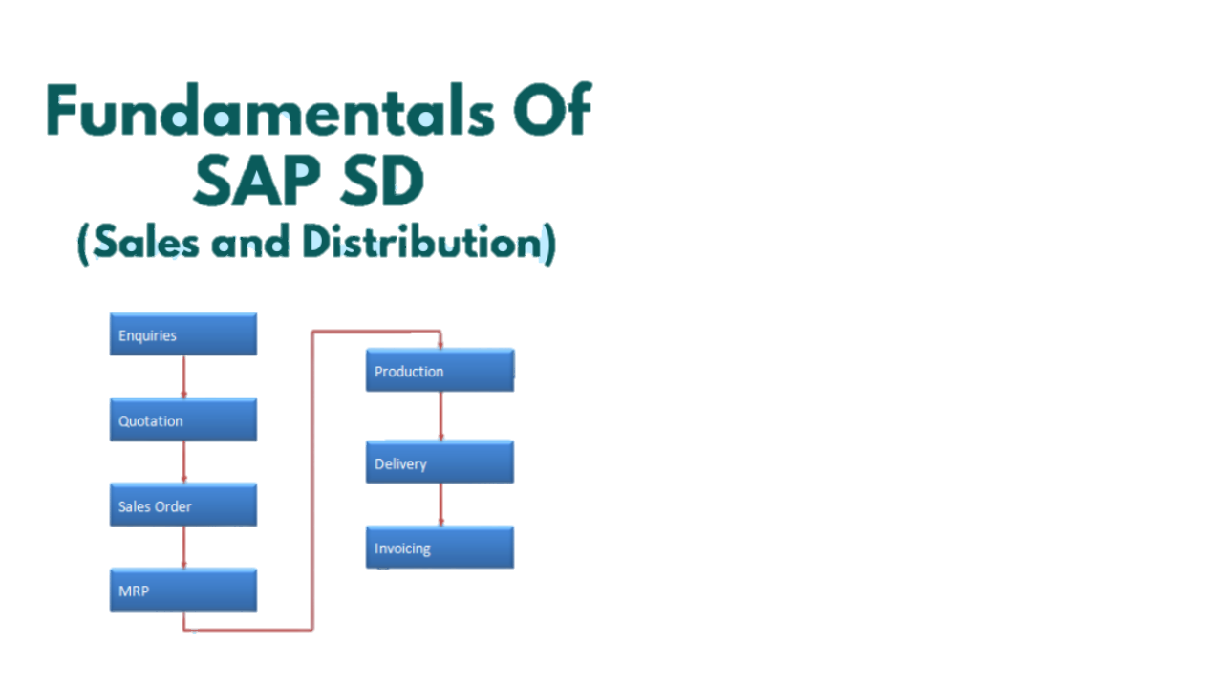



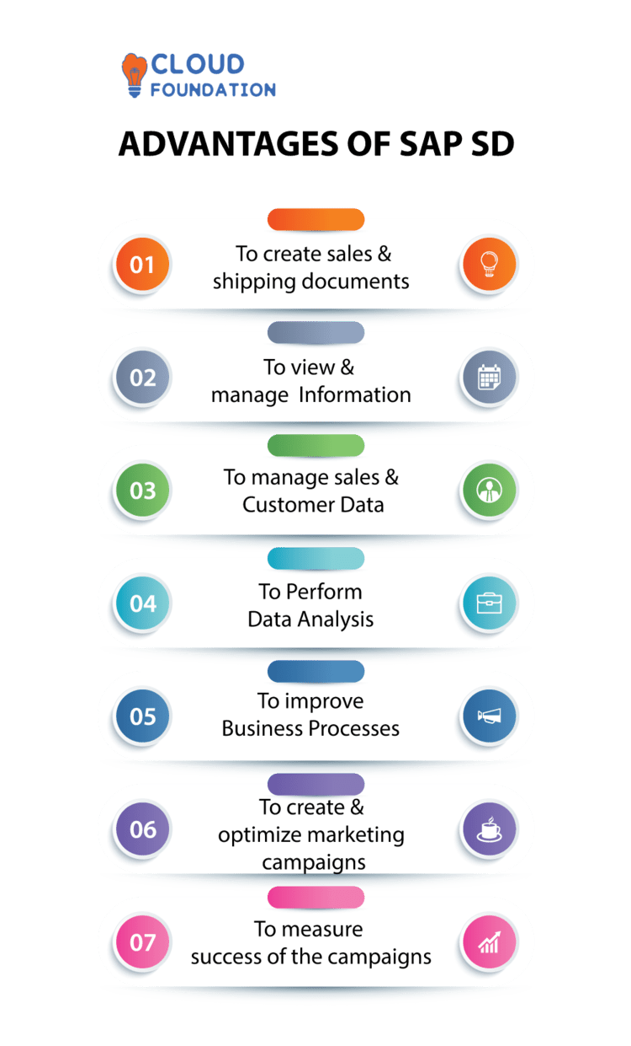

**Chapter 4**

**Placement Opportunities**

The SAP SD certification offers excellent career prospects in both domestic and international markets, as businesses across industries rely on SAP ERP for managing sales, distribution, and financial processes. In India, SAP SD professionals are highly sought after in IT services, manufacturing, retail, FMCG, e-commerce, and logistics. Companies hire SAP SD-certified candidates for roles such as SAP SD Consultant, Business Analyst, ERP Project Manager, and SAP End-User, with salaries ranging from ₹6 – 15 LPA, depending on experience.

Globally, the demand for SAP SD experts is growing, especially in regions like the USA, Canada, Germany, the UK, UAE, and Australia, where companies are implementing SAP S/4HANA. International job roles include SAP SD Functional Consultant, ERP Implementation Specialist, and SAP SD-FICO Integration Consultant, with salaries ranging from $80,000 – $120,000 per year. Additionally, professionals can explore freelance consulting and SAP training opportunities, making SAP SD a valuable skill for career advancement**.**

**4.1 Placement Opportunities in India**

The demand for SAP SD professionals in India is growing rapidly as companies increasingly adopt SAP ERP systems to optimize their sales and distribution processes. Various industries, including IT services, manufacturing, retail, FMCG, pharmaceuticals, e-commerce, and logistics, require SAP SD-certified professionals to streamline operations and enhance business efficiency.

Job Roles Available

SAP SD professionals in India can pursue various career paths, including:

* SAP SD Consultant – Configuring and implementing SAP SD solutions for businesses.
* SAP SD End-User – Managing day-to-day sales orders, billing, and logistics within SAP.
* Business Analyst (SAP SD) – Analyse sales processes and translating business needs into SAP solutions.
* SAP SD Support Consultant – Providing troubleshooting, maintenance, and technical support.
* SAP SD-FICO Integration Consultant – Handling financial aspects of sales and revenue recognition.

Industries Hiring SAP SD Professionals

SAP SD experts are in demand across multiple industries, such as:

* IT & Consulting – Infosys, TCS, Wipro, Capgemini, Accenture, Deloitte.
* Manufacturing & FMCG – Tata Steel, Hindustan Unilever, Marico, ITC, Nestlé.
* Retail & E-commerce – Flipkart, Amazon, Reliance Retail, Aditya Birla Group.
* Pharmaceuticals & Healthcare – Cipla, Dr. Reddy’s, Sun Pharma, Apollo Hospitals.
* Automotive & Logistics – Tata Motors, Mahindra & Mahindra, DHL, Blue Dart.

Salary Range in India

The salary for SAP SD professionals in India varies based on experience and job role:

* Entry-Level (0-2 years) – ₹6 – 8 LPA.
* Mid-Level (3-5 years) – ₹8 – 12 LPA.
* Senior-Level (6+ years) – ₹12 – 20 LPA or more.

**4.2 Global Placement Opportunities**

The demand for SAP SD professionals is high worldwide, as companies across industries rely on SAP ERP solutions to manage their sales, distribution, and financial processes. Many global organizations are transitioning to SAP S/4HANA, further increasing the need for skilled SAP SD consultants and analysts.

Job Roles Available Internationally

SAP SD professionals can explore various career paths in global markets, including:

* SAP SD Functional Consultant – Configuring and implementing SAP SD solutions for multinational companies.
* ERP Implementation Specialist – Managing large-scale SAP implementation projects.
* SAP SD-FICO Integration Consultant – Handling financial aspects of sales, revenue posting, and credit management.
* SAP SD Business Analyst – Working with international teams to optimize sales and distribution processes.
* SAP SD Support Consultant – Providing post-implementation support and troubleshooting.

Top Countries Hiring SAP SD Professionals

Many countries actively hire SAP SD professionals, with high demand in IT, manufacturing, retail, automotive, and logistics industries. Some of the top locations include:

* United States (USA) – IBM, Deloitte, Accenture, SAP America, Microsoft.
* Canada – CGI, SAP Canada, Capgemini, Cognizant.
* Germany – SAP SE, Siemens, Volkswagen, BMW, Bosch.
* United Kingdom (UK) – PwC, KPMG, Tata Consultancy Services, Unilever.
* United Arab Emirates (UAE) – Emirates Group, Etihad Airways, SAP MENA, ADNOC.
* Australia – Woolworths, Rio Tinto, Telstra, SAP Australia.

Salary Range in Global Markets

The salary for SAP SD professionals varies by region, experience, and job role:

* United States (USA) – $80,000 – $120,000 per year.
* Canada – CAD 75,000 – CAD 110,000 per year.
* Germany – €60,000 – €100,000 per year.
* United Kingdom (UK) – £50,000 – £85,000 per year.
* United Arab Emirates (UAE) – AED 200,000 – AED 350,000 per year.
* Australia – AUD 90,000 – AUD 130,000 per year.

**4.3 Entrepreneurial Opportunities**

SAP SD professionals can explore entrepreneurial opportunities by leveraging their expertise in ERP consulting, training, and SAP implementation services. With businesses of all sizes adopting SAP S/4HANA, there is a growing demand for independent consultants and service providers specializing in SAP SD.

**1. SAP SD Freelance Consulting**

* Providing SAP SD implementation, customization, and support for small and mid-sized businesses.
* Assisting companies with SAP SD-FICO integration and pricing configuration.
* Offering post-implementation troubleshooting and optimization services.
* Platforms for freelancing: Upwork, Fiverr, Freelancer, Toptal.

**2. SAP SD Training and Coaching**

* Creating SAP SD online courses and tutorials for beginners and professionals.
* Offering corporate SAP training programs for companies migrating to SAP.
* Providing one-on-one mentorship for SAP SD certification aspirants.
* Platforms for training: Udemy, Coursera, LinkedIn Learning, YouTube.

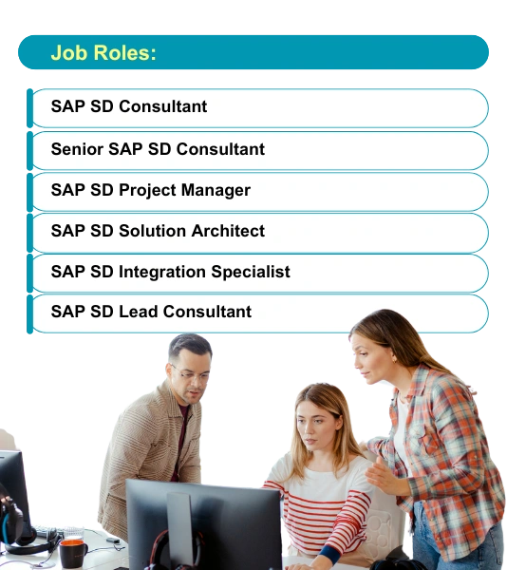**3. Starting an SAP SD Consulting Firm**

* Establishing a company specializing in SAP ERP implementation and support.
* Partnering with businesses for SAP upgrades and S/4HANA migration.
* Offering customized SAP SD solutions tailored to specific industries**.**

**Chapter 5**

**Learning Experience**

The SAP SD (Sales and Distribution) training provided a structured and hands-on learning experience, covering both theoretical concepts and practical applications. Through 31.5 hours of online training on Udemy, I gained in-depth knowledge of the Order-to-Cash (O2C) cycle, master data management, pricing, billing, logistics, and SAP SD integration with SAP MM and SAP FICO.

The course offered a real-world business perspective, enabling me to work with sales orders, delivery processing, invoicing, and financial postings in a simulated SAP environment. The step-by-step demonstrations helped in understanding complex SAP SD functionalities such as pricing procedures, condition techniques, and credit management. Additionally, hands-on exercises involving sales order creation, delivery scheduling, and invoice generation strengthened my ability to configure and execute SAP SD processes efficiently.

The training also presented challenges, such as understanding SAP SD configuration settings, troubleshooting errors, and ensuring seamless integration with other modules. However, these challenges were valuable learning experiences, helping me build problem-solving skills and a deeper understanding of SAP SD’s business applications.

Overall, this training has enhanced my technical expertise, improved my ability to manage sales processes, and prepared me for SAP SD consulting, ERP implementation, and business process optimization roles.

**5.1 Brief on New Skills Learned**

**5.1.1.** **Hands-on Experience with SAP SD Transactions and Configurations**

The SAP SD training provided extensive hands-on practice in executing key transactions and configuring essential elements within the Sales and Distribution (SD) module. Through real-time simulations and practical exercises, I gained experience in managing the entire sales cycle, from order creation to billing and financial integration.

Key SAP SD Transactions Practiced:

* Sales Order Processing (VA01, VA02, VA03) – Creating, modifying, and tracking customer orders.
* Pricing and Discounts (VK11, VK12, VK13) – Configuring condition types, pricing procedures, and customer-specific discounts.
* Delivery and Shipping (VL01N, VL02N, VL03N) – Scheduling deliveries, managing picking and packing, and posting goods issue.
* Billing and Invoicing (VF01, VF02, VF03) – Generating invoices, credit/debit memos, and integrating with SAP FICO.
* Credit Management (FD32) – Configuring credit limits and monitoring financial risks.

The hands-on practice helped in understanding SAP SD configurations, such as defining sales document types, setting up item categories, configuring partner functions, and integrating SD with MM and FICO. Working directly with SAP transactions enhanced my problem-solving skills, technical expertise, and ability to manage real-world sales processes effectively.

**5.1.2.** **Understanding Real-World Business Scenarios and Problem-Solving in Sales & Distribution**

The SAP SD training provided a **practical understanding of real-world business scenarios**, helping to develop problem-solving skills in **sales and distribution processes**. By working through **case studies and hands-on exercises**, I gained insights into how SAP SD is used to address business challenges, improve efficiency, and optimize sales operations.

**Key Real-World Scenarios Covered:**

* **Handling Stock Shortages** – Understanding how SAP SD interacts with SAP MM to manage backorders and suggest alternative delivery dates.
* **Managing Customer-Specific Pricing** – Configuring discounts, rebates, and special pricing conditions for different customer groups.
* **Processing Returns and Refunds** – Managing credit memos, return orders, and stock adjustments.
* **Credit Management and Risk Control** – Implementing credit limits to minimize financial risks and automate order approvals.
* **Order Fulfillment and Logistics Issues** – Resolving delayed shipments, optimizing delivery routes, and integrating with warehouse management.

By applying SAP SD configurations to **real-world business challenges**, I learned how to troubleshoot issues, enhance operational efficiency, and ensure seamless **order processing, billing, and customer satisfaction**. This problem-solving experience has strengthened my ability to work in **SAP consulting, ERP implementation, and business process optimization** roles.

**5.2 Challenges Faced During Training**

**5.2.1. Complexity in Configuring Pricing and Discounts in SAP SD**

Configuring pricing and discounts in SAP SD is a complex process due to the multiple condition types, pricing procedures, and business-specific requirements that must be considered. The SAP pricing mechanism is highly flexible, but its configuration requires a deep understanding of condition techniques, access sequences, and calculation rules.

Key Challenges in Pricing Configuration:

* Multiple Condition Types – Managing different pricing components such as base price (PR00), discounts (KA00), freight charges (FR00), and taxes (MWST) while ensuring they apply correctly in sales orders.
* Pricing Procedure Complexity – Defining the correct sequence of condition types, ensuring the right conditions are applied at different stages of sales transactions.
* Customer-Specific Pricing – Configuring special discounts, rebates, and contracts that vary based on customer groups, material types, and regional pricing rules.
* Tax Calculation and Compliance – Ensuring proper application of GST, VAT, and sales tax based on country-specific regulations.
* Integration with Financial Accounting (SAP FICO) – Ensuring that pricing elements are correctly reflected in financial postings, preventing revenue miscalculations.

**5.2.2. Understanding SAP SD Integration with MM and FICO**

The SAP SD (Sales and Distribution) module is closely integrated with SAP MM (Material Management) and SAP FICO (Finance & Controlling) to ensure seamless business operations. This integration allows businesses to automate sales processes, track inventory levels, and manage financial transactions efficiently.

**1. Integration with SAP MM (Material Management)**

SAP SD and MM work together to manage inventory and product availability for sales orders. Key integration points include:

* Stock Availability Check – When a sales order is created in SD (VA01), the system checks inventory in MM.
* Goods Issue (Post Goods Issue - PGI) – When a product is shipped (VL01N), stock is reduced in MM, and an accounting entry is triggered.
* Procurement and Sales Link – If stock is unavailable, MM triggers purchase requisitions or stock transfers.

**2. Integration with SAP FICO (Finance & Controlling)**

SAP SD and FICO integration ensures that sales transactions are recorded in financial accounting for revenue tracking. Key integration points include:

* Invoice Posting – When billing is processed in SD (VF01), an automatic accounting entry is posted in FICO.
* Revenue Recognition – Sales revenue is recorded in the General Ledger (G/L).
* 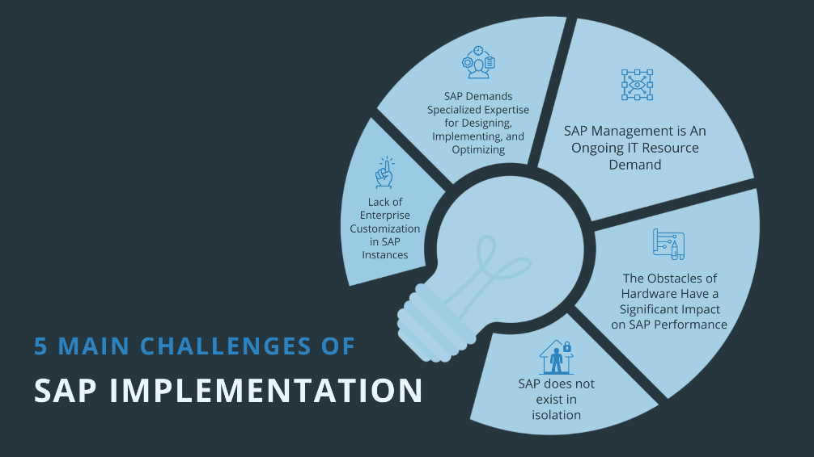Accounts Receivable (A/R) Updates – Customer invoices are recorded under accounts receivable, allowing for payment tracking.
  + Credit Management – FICO credit limits (FD32) ensure that customers do not exceed their financial capacity before a sales order is processed.

**CONCLUSION**

The SAP SD (Sales and Distribution) training has been an invaluable learning experience, providing a strong foundation in sales order management, pricing, billing, logistics, and financial integration within SAP ERP. This training not only covered theoretical concepts but also emphasized practical application through hands-on exercises, making it highly relevant for real-world business scenarios.

A major highlight of this training was gaining a thorough understanding of the Order-to-Cash (O2C) cycle, which is the backbone of the sales and distribution process in SAP. The ability to create and manage sales orders, configure pricing and discount structures, schedule deliveries, and generate invoices ensures that businesses can efficiently handle customer transactions. Furthermore, learning about credit management and risk control has provided valuable insights into how companies manage customer credit limits, prevent financial losses, and optimize cash flow.

One of the most significant aspects of the training was SAP SD integration with SAP MM (Material Management) and SAP FICO (Finance and Controlling). This integration ensures that stock availability, inventory updates, and financial postings occur automatically, reducing errors and improving business efficiency. The ability to process sales orders, check stock levels, generate invoices, and track revenue postings in financial accounts demonstrated the importance of cross-functional SAP modules working seamlessly together.

The training also provided deep insights into pricing and discount mechanisms, which are crucial for businesses dealing with large-scale sales transactions, special customer pricing, and taxation rules. The complexity of configuring pricing procedures, condition records, and tax calculations was challenging, but overcoming these challenges enhanced problem-solving skills and reinforced the importance of accuracy in pricing management.

The hands-on experience with SAP SD transactions was one of the most valuable aspects of the training. Performing real-time exercises using key SAP SD transactions such as VA01 (Sales Order Creation), VL01N (Delivery Processing), and VF01 (Invoice Generation) helped in understanding how businesses process customer orders, manage deliveries, and handle financial reconciliations. Additionally, learning how to configure partner functions, item categories, and schedule line categories provided deeper knowledge of how SAP SD adapts to different business needs.While the training was comprehensive, it also introduced challenges, particularly in configuring pricing conditions, integrating financial postings, and troubleshooting sales order errors. However, these challenges played a crucial role in enhancing analytical thinking and technical expertise in SAP SD. They also reinforced the importance of attention to detail, process accuracy, and system troubleshooting skills—all of which are essential for professionals working in SAP consulting, ERP implementation, and business process optimization.

In conclusion, this SAP SD training has been an enriching and transformative experience, equipping me with the necessary skills to work effectively in SAP SD consulting, ERP implementation, and business process management roles. The ability to configure SAP SD solutions, understand business requirements, and troubleshoot real-world challenges will be essential in contributing to organizational success and digital transformation initiatives in the SAP ecosystem. Moving forward, I aim to apply these learnings in a practical work environment while continuing to explore advanced SAP modules and specialized certifications for further career growth.

**References**

The following references were used in compiling this report, providing theoretical knowledge, technical insights, and practical applications related to SAP SD:

* Online Courses and Training Materials
* Udemy – SAP SD Certification Training *(31.5-hour online course completed as part of this training)*
* SAP Learning Hub – SAP SD Documentation & User Guides
* Open SAP – Free SAP SD Learning Resources and Webinars
* Official SAP Documentation and Notes
* SAP Help Portal – SD Module (<https://help.sap.com/>)
* SAP Community – Discussion Forums & Technical Guides (<https://community.sap.com/>)
* SAP Notes & Knowledge Base Articles (<https://launchpad.support.sap.com/>)
* Web Articles and Industry Reports
* SAP SD Integration with MM and FICO – Blog post on SAP Insights (<https://insights.sap.com/>)
* SAP S/4HANA Sales & Distribution – Latest Updates – Article on SAP Blogs (<https://blogs.sap.com/>)
* Images Used in this project –

1. <https://shorturl.at/Y60nc>
2. <https://shorturl.at/vx9U7>
3. <https://shorturl.at/DnZBg>
4. <https://shorturl.at/EOL9r>
5. <https://shorturl.at/ftDDh>
6. <https://shorturl.at/y0h6v>

* Certificate authorisation link - <https://shorturl.at/2cnRi>